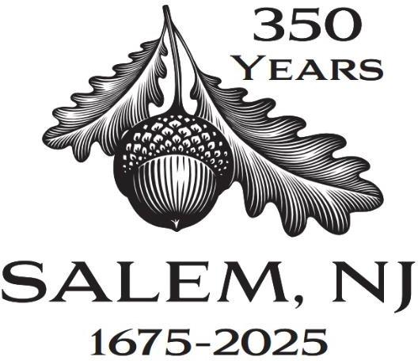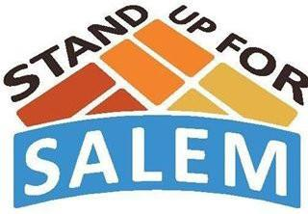

March 19, 2025

Dear Friend,

Thank you for your support of Stand Up for Salem. We are excited to be coordinating the efforts for an incredible milestone year in 2025 - **Salem City’s 350th Anniversary**, and we hope we can count on you to join in the celebration as a sponsor.

Throughout 2025, we will highlight the history, culture, and community pride of this great city. In fact, the party has already started, with the mayor’s proclamation at the City Council Reorganization on January 4th. With anniversary banners hanging on Broadway and Market Streets, refreshed “Welcome to Salem” signage, and storefront façade improvements, Salem will shine brighter than ever this year and position itself to thrive for years to come. This will all culminate with a Main Event – a day-long celebration on Saturday, October 4th.

Leading up to that date there are a variety of opportunities to capitalize on your sponsorship, including social media segments, a memorial brick, recognition and attendance at the Anniversary Dinner on April 11th, and our annual community Block Party on June 6th.

Please consider how you can help and be part of this historic year. Checks can be made payable to “Stand Up for Salem" and sent to PO Box 33, Salem NJ, 08079.  If you have questions, please visit the website [www.StandUpForSalem.com](http://www.standupforsalem.org), or contact Betsy McBride at 856-935-1248 or standupforsalem@gmail.com.

**PLATINUM YEAR-LONG SPONSOR - $25,000**

* Recognition on materials: print/online/website
* 2-Minute “Sponsor Segment” at ALL events
* Banner recognition at all events
* Social media segments promoting your business
* Memorial Brick – 8 x 8, company name

**DIAMOND SPONSOR - $15,000**

* Recognition on materials: print/online/website
* Stage recognition at Block Party and Main Event
* Banner recognition at Block Party and Main Event
* Memorial Brick – 8 x 8, company name

**GOLD SPONSOR - $10,000**

* Recognition on materials: print/online/website
* Stage recognition at Main Event
* Banner recognition at Main Event
* Memorial Brick – 8 x 8, company name

**SILVER SPONSOR - $5,000**

* Recognition on materials: print/online/website
* Stage recognition at Block Party
* Banner recognition at Main Event
* Memorial Brick – 8 x 8, company name

**SALEM OAK SPONSOR - $2,500**

* Recognition on materials: print/online/website
* Recognition at Reenactment Event
* Banner recognition at Main Event
* Memorial Brick – 8 x 8, company name

**ACORN SPONSOR - $1,000**

* Recognition on materials: print/online/website
* Banner recognition at Main Event
* Memorial Brick – 8 x 8, company name

**PLEASE SEND YOUR ARTWORK (JPEG) TO:** [**standupforsalem@gmail.com**](mailto:standupforsalem@gmail.com)**. DEADLINE: April 15, 2025**

Stand Up for Salem, PO Box 33, Salem, NJ 08079 [standupforsalem@gmail.com](mailto:standupforsalem@gmail.com) standupforsalem.com o: 856.935.1248, c: 856.628.6046 501c3 Tax ID 22-2908783